GCP Fundamentals: Getting Started with Deployment Manager and Stackdriver

45 minutesFree

Rate Lab

**Overview**

In this lab, you create a deployment using Deployment Manager and use it to maintain a consistent state of your deployment. You will also view resource usage in a VM instance using Cloud Monitoring.

**Objectives**

In this lab, you will learn how to perform the following tasks:

* Create a Deployment Manager deployment.
* Update a Deployment Manager deployment.
* View the load on a VM instance using Cloud Monitoring.

**Task 1: Sign in to the Google Cloud Platform (GCP) Console**

For each lab, you get a new GCP project and set of resources for a fixed time at no cost.

1. Make sure you signed into Qwiklabs using an **incognito window**.
2. Note the lab's access time (for example, img/time.png and make sure you can finish in that time block.

There is no pause feature. You can restart if needed, but you have to start at the beginning.

1. When ready, click img/start_lab.png.
2. Note your lab credentials. You will use them to sign in to Cloud Platform Console. 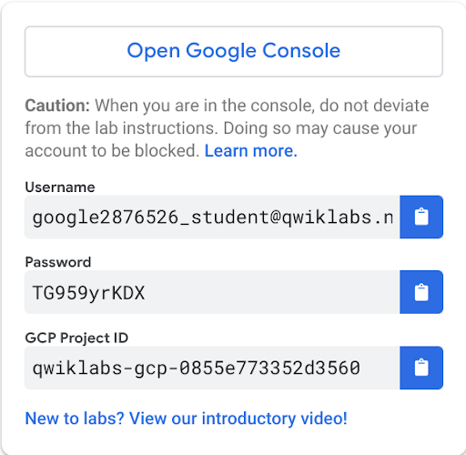
3. Click **Open Google Console**.
4. Click **Use another account** and copy/paste credentials for **this** lab into the prompts.

If you use other credentials, you'll get errors or **incur charges**.

1. Accept the terms and skip the recovery resource page.

Do not click **End Lab** unless you are finished with the lab or want to restart it. This clears your work and removes the project.

**Task 2: Confirm that needed APIs are enabled**

1. Make a note of the name of your GCP project. This value is shown in the top bar of the Google Cloud Platform Console. It will be of the form qwiklabs-gcp- followed by hexadecimal numbers.
2. In the GCP Console, on the **Navigation menu** (), click **APIs & services**.
3. Scroll down in the list of enabled APIs, and confirm that these APIs are enabled:

* Cloud Deployment Manager v2 API
* Cloud Runtime Configuration API
* Cloud Monitoring API

1. If one or more APIs is missing, click the **Enable APIs and Services** button at top. Search for the above APIs by name and enable each for your current project. (You noted the name of your GCP project above.)

**Task 3: Create a Deployment Manager deployment**

1. In GCP console, on the top right toolbar, click the Open Cloud Shell button (). Click **Continue**.
2. For your convenience, place the zone that Qwiklabs assigned you to into an environment variable called MY\_ZONE. At the Cloud Shell prompt, type this partial command:

export MY\_ZONE=

followed by the zone that Qwiklabs assigned you to. Your complete command will look like this:

export MY\_ZONE=us-central1-a

1. At the Cloud Shell prompt, download an editable Deployment Manager template:

gsutil cp gs://cloud-training/gcpfcoreinfra/mydeploy.yaml mydeploy.yaml

1. Insert your Google Cloud Platform project ID into the file in place of the string PROJECT\_ID using this command:

sed -i -e 's/PROJECT\_ID/'$DEVSHELL\_PROJECT\_ID/ mydeploy.yaml

1. Insert your assigned Google Cloud Platform zone into the file in place of the string ZONE using this command:

sed -i -e 's/ZONE/'$MY\_ZONE/ mydeploy.yaml

1. View the mydeploy.yaml file, with your modifications, with this command:

cat mydeploy.yaml

The file will look something like this:

resources:

- name: my-vm

type: compute.v1.instance

properties:

zone: us-central1-a

machineType: zones/us-central1-a/machineTypes/n1-standard-1

metadata:

items:

- key: startup-script

value: "apt-get update"

disks:

- deviceName: boot

type: PERSISTENT

boot: true

autoDelete: true

initializeParams:

sourceImage: https://www.googleapis.com/compute/v1/projects/debian-cloud/global/images/debian-9-stretch-v20180806

networkInterfaces:

- network: https://www.googleapis.com/compute/v1/projects/qwiklabs-gcp-dcdf854d278b50cd/global/networks/default

accessConfigs:

- name: External NAT

type: ONE\_TO\_ONE\_NAT

Do not use the above text literally in your own **mydeploy.yaml** file. Be sure that the zone that is named on the **zone:** and **machineType:** lines in your file matches the zone to which Qwiklabs assigned you. Be sure that the GCP project ID on the **network:** line in your file matches the project ID to which Qwiklabs assigned you, not the one in this example.

1. Build a deployment from the template:

gcloud deployment-manager deployments create my-first-depl --config mydeploy.yaml

When the deployment operation is complete, the **gcloud** command displays a list of the resources named in the template and their current state.

1. Confirm that the deployment was successful. In the GCP Console, on the **Navigation menu** (), click **Compute Engine > VM instances**. You will see that a VM instance called **my-vm** has been created, as specified by the template.
2. Click on the VM instance's name to open its VM instance details screen.
3. Scroll down to the **Custom metadata** section. Confirm that the startup script you specified in your Deployment Manager template has been installed.

Click *Check my progress* to verify the objective.

Create a Deployment Manager deployment

Check my progress

**Task 4: Update a Deployment Manager deployment**

1. Return to your Cloud Shell prompt. Launch the nano text editor to edit the **mydeploy.yaml** file:

nano mydeploy.yaml

1. Find the line that sets the value of the startup script, value: "apt-get update", and edit it so that it looks like this:

value: "apt-get update; apt-get install nginx-light -y"

Do not disturb the spaces at the beginning of the line. The YAML templating language relies on indented lines as part of its syntax. As you edit the file, be sure that the v in the word value in this new line is immediately below the k in the word key on the line above it.

1. Press **Ctrl+O** and then press **Enter** to save your edited file.
2. Press **Ctrl+X** to exit the **nano** text editor.
3. Return to your Cloud Shell prompt. Enter this command to cause Deployment Manager to update your deployment to install the new startup script:

gcloud deployment-manager deployments update my-first-depl --config mydeploy.yaml

Wait for the **gcloud** command to display a message confirming that the update operation was completed successfully.

1. In the GCP console, on the **Navigation menu** (), click **Compute Engine > VM instances**.
2. Click on the **my-vm** VM instance's name to open its **VM instance details** pane.
3. Scroll down to the **Custom metadata** section. Confirm that the startup script has been updated to the value you declared in your Deployment Manager template.

Click *Check my progress* to verify the objective.

Update the Deployment Manager deployment

Check my progress

**Task 5: View the Load on a VM using Cloud Monitoring**

1. In the GCP Console, on the **Navigation menu** (), click **Compute Engine** > **VM instances**.
2. To open a command prompt on the **my-vm** instance, click **SSH** in its row in the **VM instances** list.
3. In the ssh session on **my-vm**, execute this command to create a CPU load:

dd if=/dev/urandom | gzip -9 >> /dev/null &

This Linux pipeline forces the CPU to work on compressing a continuous stream of random data.

Leave the window containing your SSH session open while you proceed with the lab.

Create a Monitoring workspace

You will now setup a Monitoring workspace that's tied to your Qwiklabs GCP Project. The following steps create a new account that has a free trial of Monitoring.

1. In the Google Cloud Platform Console, click on **Navigation menu** > **Monitoring**.
2. Wait for your workspace to be provisioned.

When the Monitoring dashboard opens, your workspace is ready.

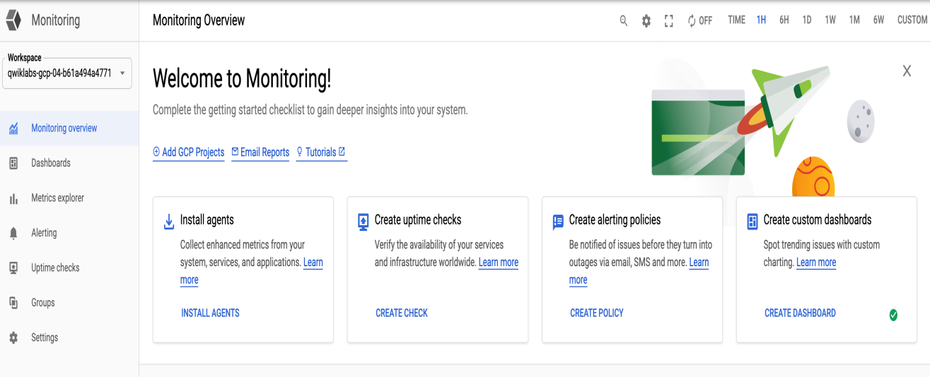

1. Click on **Settings** option from the left panel and confirm that the GCP project which Qwiklabs created for you is shown under the **GCP Projects** section.

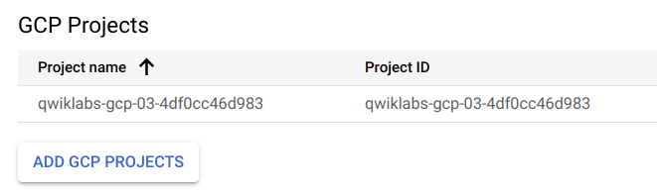

1. Under the **Settings** tab menu, click **Agent**. Using your VM's open SSH window and the code shown on the Agents page, install both the Monitoring and Logging agents on your project's VM.
2. Once both of the agents have been installed on your project's VM, click **Metrics Explorer** under the main Cloud Monitoring menu on the far left.
3. In the **Metric** pane of **Metrics Explorer**, select the resource type **GCE VM instance** and the metric **CPU usage**.

In the resulting graph, notice that CPU usage increased sharply a few minutes ago.

1. Terminate your workload generator. Return to your ssh session on **my-vm** and enter this command:

kill %1